EXERCISE 7
- List the names of 5 youngest employees in the company.
SELECT f_name, l_name, age
FROM employee_data
ORDER BY age ASC
LIMIT 5;
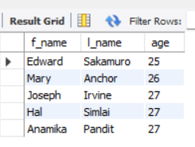
- Extract the next 5 entries starting with the 10 row.
SELECT *
FROM employee_data
LIMIT 5 OFFSET 10;
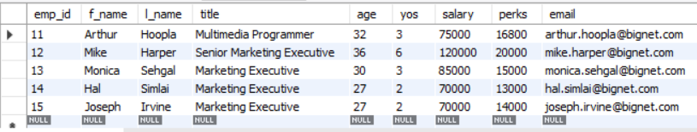
- Display the names and salary of the employee who draws the largest salary.
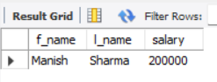
SELECT f_name, l_name, salary
FROM employee_data
ORDER BY salary DESC
LIMIT 1;

- What does the following statement display? SELECT emp_id, age, perks from employee_data ORDER BY perks DESC LIMIT 10:
SELECT emp_id, age, perks
FROM employee_data
ORDER BY perks DESC
LIMIT 10;
